Ideation Phase
Brainstorm & Idea Prioritization Template

Date | 31 January 2025
Team ID | SWTID-2026-2491
Project Name | AI BlogNest API
Maximum Marks | 4 Marks

Brainstorm & Idea Prioritization Template:
The Brainstorm & Idea Prioritization Template in the AI BlogNest API is a structured tool designed to help users generate, organize, evaluate, and prioritize blog content ideas. It uses AI to transform basic topics or keywords into meaningful content suggestions based on audience needs, relevance, creativity, and potential engagement. Each idea can be analyzed and assigned a priority level to help users identify which topics should be developed first. The template supports efficient content planning by reducing manual research and decision-making effort. It helps bloggers maintain a clear content strategy, discover new opportunities, and create consistent, relevant, and engaging blog posts.

Step-1: Team Gathering, Collaboration and Select the Problem Statement
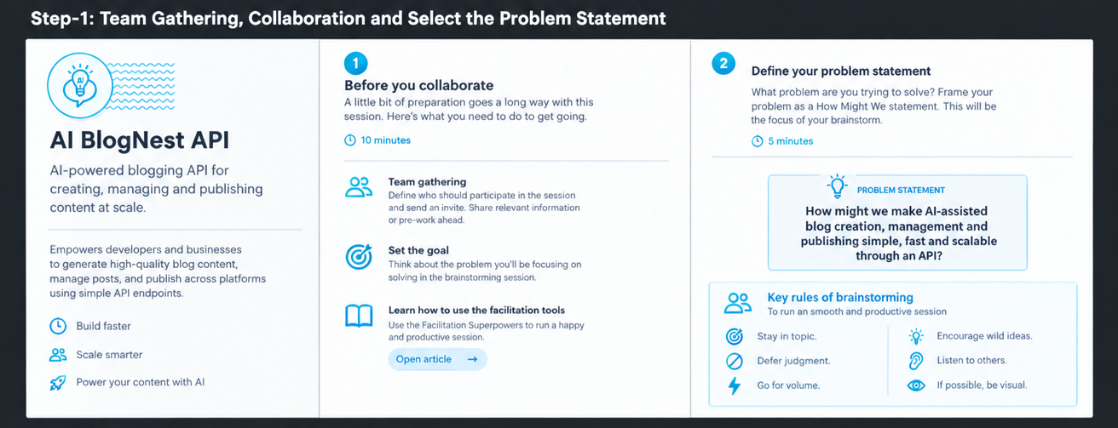

Step-2: Brainstorm, Idea Listing and Grouping
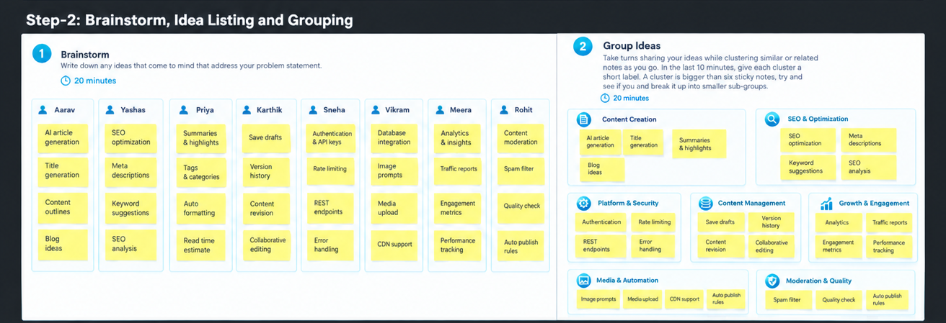

Step-3: Idea Prioritization
